**It’s Influenza Season！**

**1　Main Symptoms**　**※If you show symptoms, go to the hospital quickly**

○A sudden fever over 38 $°$ C

○Coughing, sore throat, joint pain

○Fatigue or sluggishness

　※The elderly, children, and those pregnant or chronically ill should be especially careful

**2　Flu Season**

○Peaks from January to February. However, it can continue into May

**3　How the Flu Spreads**

○Virus carried through coughs can enter your nose or mouth

○Touching a surface an infected person has touched



**4　Prevention**

**（1）After returning home, wash you hands well**

○If possible, use hand sanitizer

**（2）Get your nutrition, and sleep well**

○Strengthen your immune system to prevent the flu

**（3）Getting a vaccination is even more effective**

○Even if you catch the flu, it will prevent more serious symptoms

**5　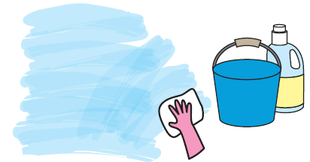If you catch the flu　※Be careful not to spread it to others**

○Ventilate the room once an hour

○People with and without the flu should wear masks

○Wash your hands well

○Other people can still catch your flu up to 2 days after you fever goes down. Avoid going to school or work